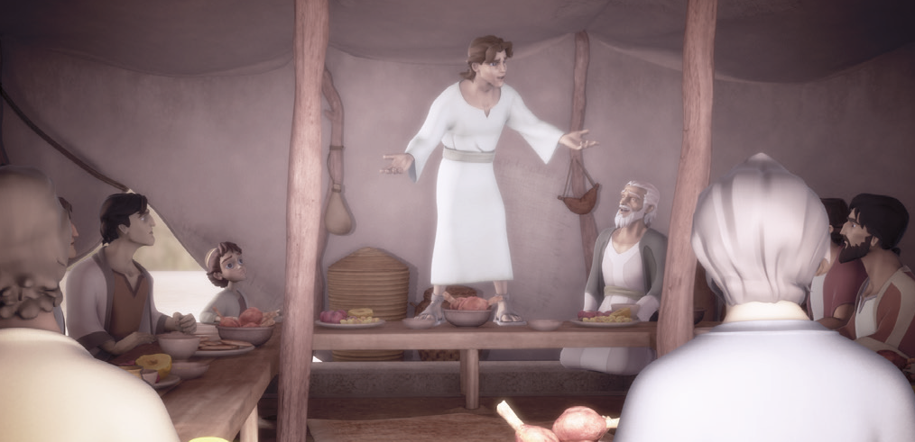
Joseph and Pharaoh’s Dream
Bible Story Genesis 37, 39-45
The Pit

At Home

Family members don’t always get along- and that was true when Joseph was growing up.
Read Genesis 37:2-4
What did Joseph’s brothers think when he told them his dreams? Read Genesis 37:5-8.
What did they do to him after that? Read Genesis 37:18-32

In the Morning
Even though we all get jealous sometimes, should we ever hate people or treat them badly?
Read James 3:16-18

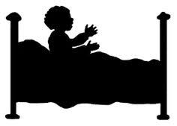

At Bedtime
If you could give some advice to Joseph’s brothers, what would you tell them?
Read Matthew 6:33

PRAY: Dear God, Please help me not to be jealous when I think others are being treated better than me. Thank you for giving me everything I need. Amen.

Cut here to put in your vehicle. --------------------------------------------------------------------------------------------------------------------------

On the Go
Superverse: “Trust in the Lord with all your heart; do not depend on your own understanding.”
Proverbs 3:5 (NLT)

